Level 2 — Excel for Engineering Data ⭐

2. Your Level 2 Practice Questions ⭐
Don't try everything at once. Do them in order.

Part A — SUMIFS, COUNTIFS, AVERAGEIFS
Q1. Find total Production for the Production department.
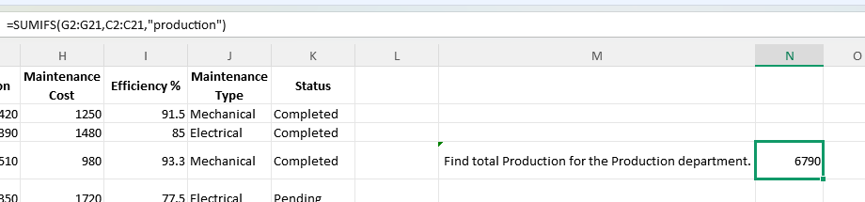
Q2. Find total Maintenance Cost for Mechanical maintenance.
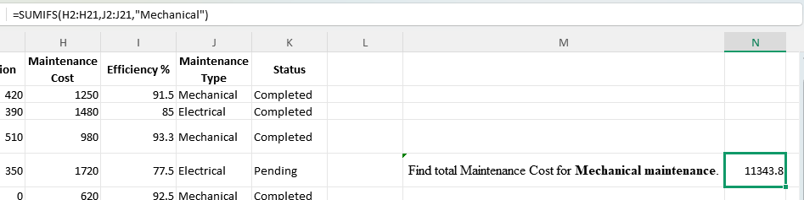
Q3. Find average Efficiency of the Production department.
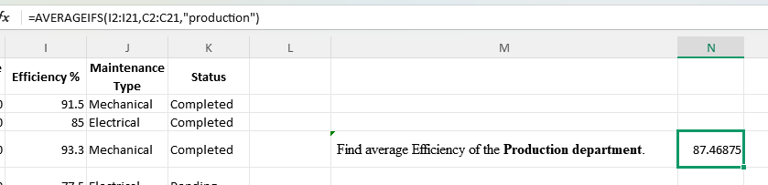
Q4. Find total Downtime for M-101.
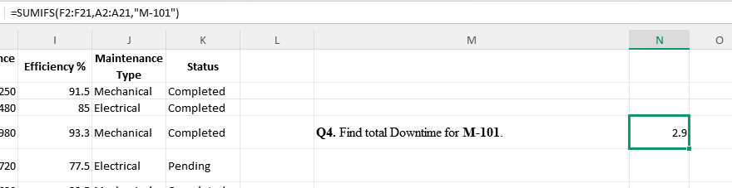
Q5. Count how many records have Pending status.
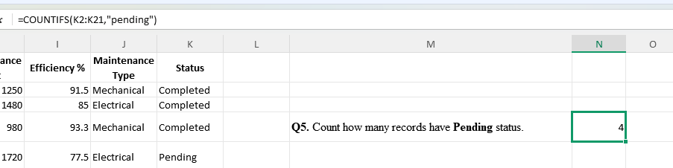
Q6. Count how many records have Efficiency greater than 90%.
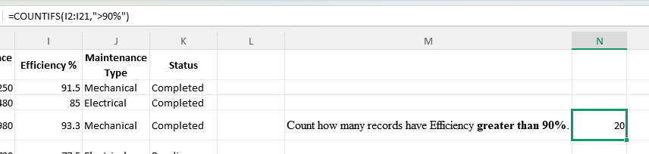
Q7. Find average Maintenance Cost for February 2026.
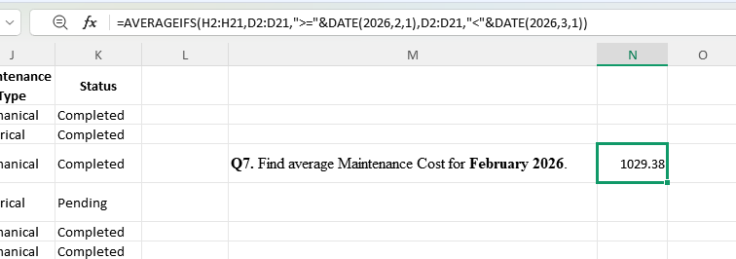

Q8. Find total Production of M-104 during February 2026.
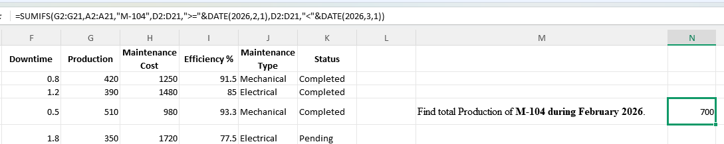

Part B — XLOOKUP / VLOOKUP
Create another small table:
Q9. Enter M-103 and find its Machine name using XLOOKUP.
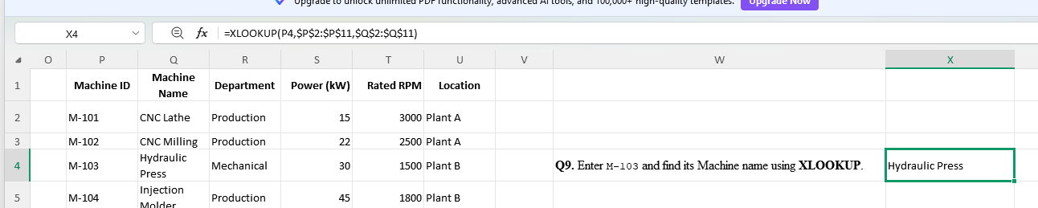
Q10. Find its Department using XLOOKUP.
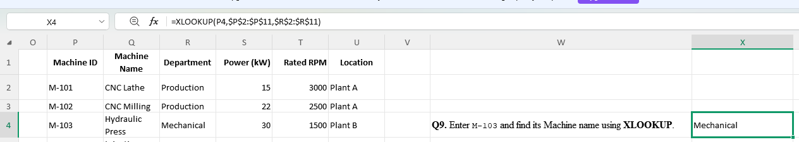
Q11. Find its Maintenance Type.
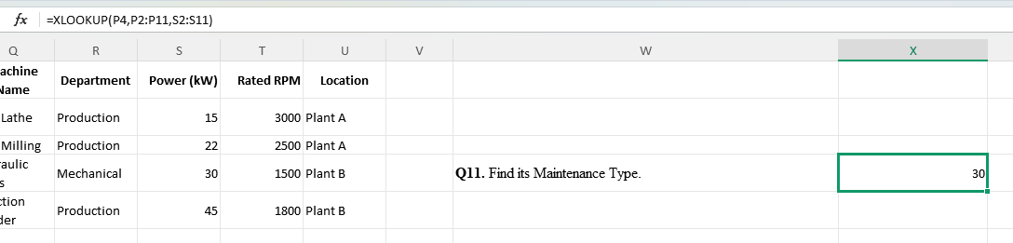

Q12. Enter an invalid ID such as M-999. Use IFERROR so Excel displays:
Not Found
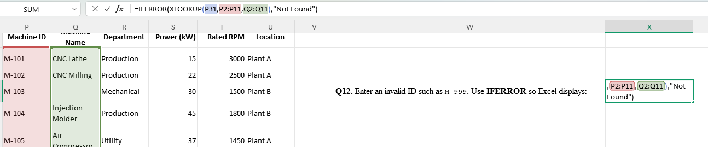

Part C — INDEX + MATCH
Q13. Use INDEX + MATCH to find the Machine name from a Machine ID.
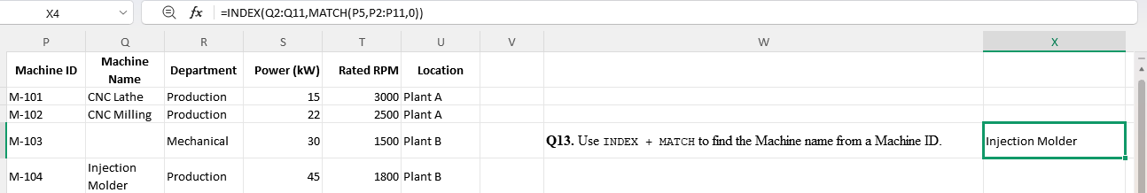
Q14. Use INDEX + MATCH to find the Efficiency of a selected Machine.
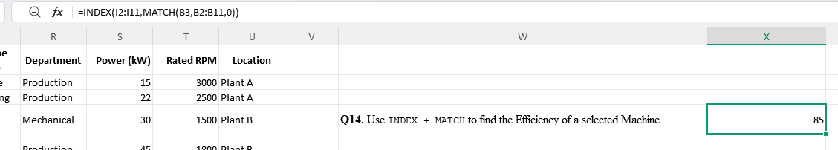

Part D — ROUND functions
Q15. Calculate average Efficiency and round it to 2 decimal places.
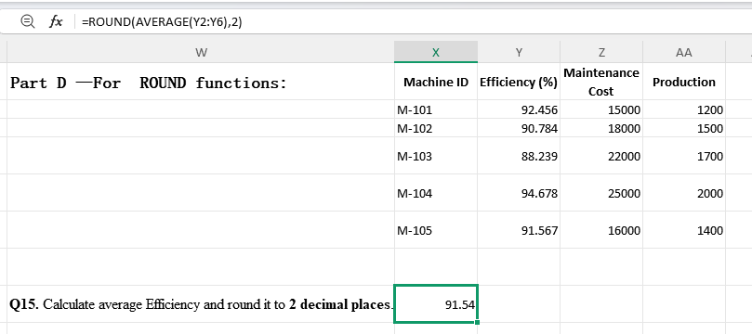
Q16. Calculate:
Maintenance Cost ÷ Production
and round the answer to 2 decimals.
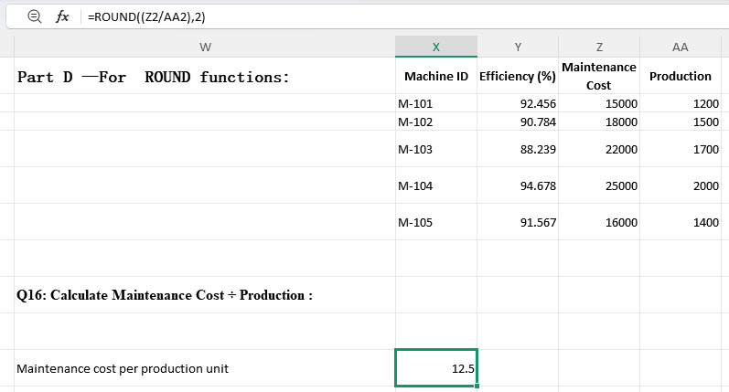
Q17. Round total Production to the nearest 100.
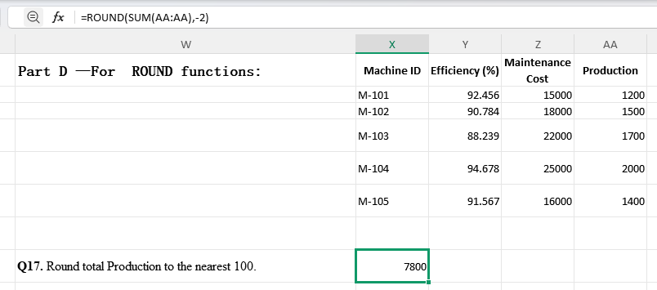
Q18. Take Maintenance Cost and practice:
- ROUND
- ROUNDUP
- ROUNDDOWN

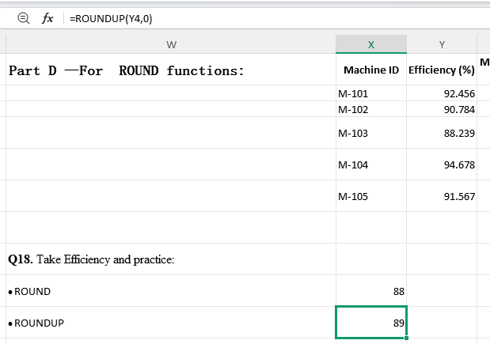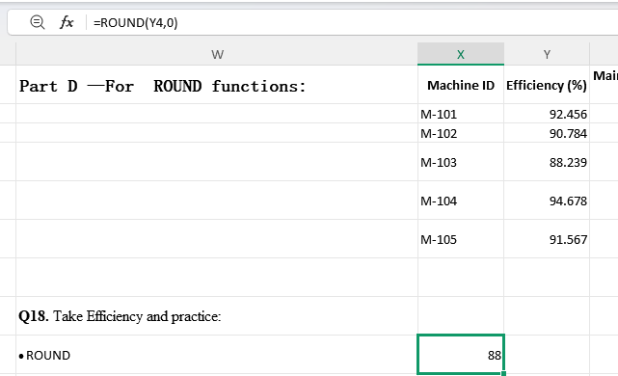
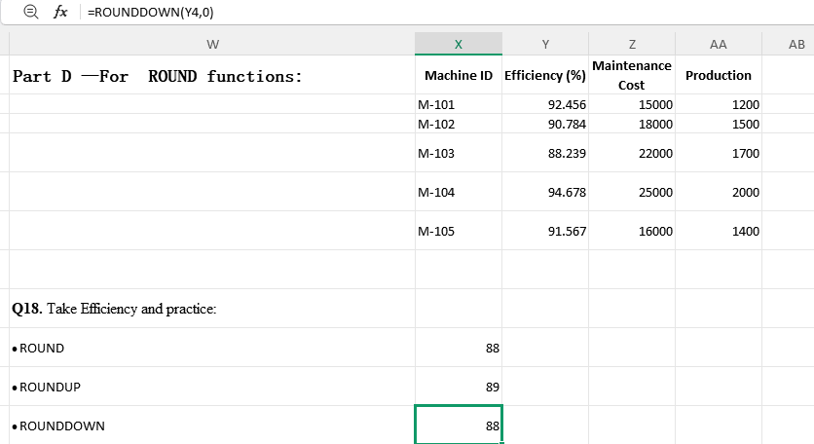
Compare the results.

Part E — Date & Time
Q19. Extract the month number from Date.
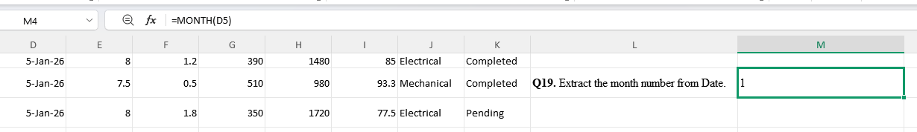
Q20. Extract the year from Date.
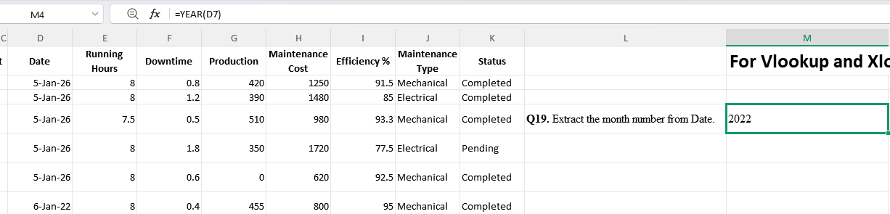
Q21. Display the month name, such as:
January
February
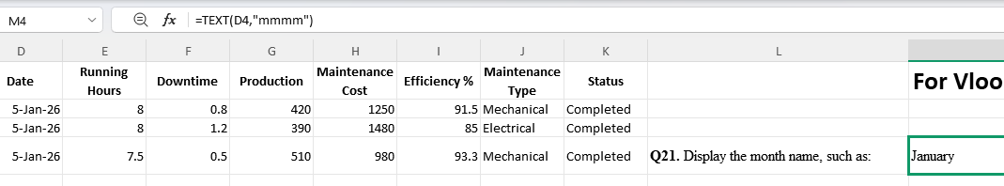
Q22. Find the number of days between each date and 01-Jan-2026.
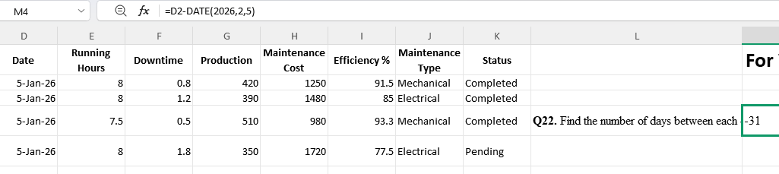
Q23. Find total Production in January 2026.
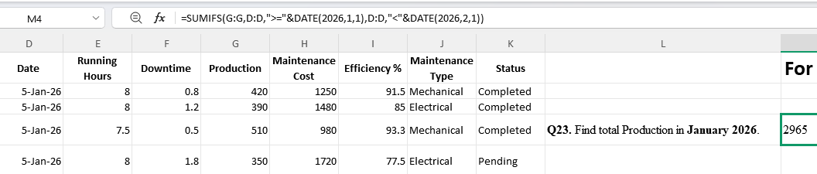
Q24. Find total Production in February 2026.
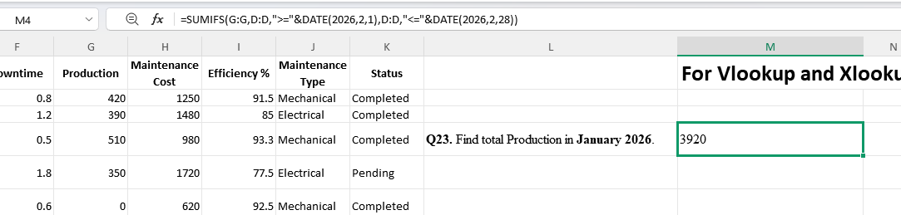

Part F — Text Functions
Q25. Create:
M-101 - CNC Lathe
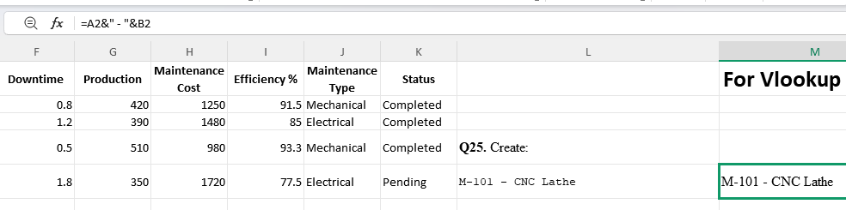
using & or TEXTJOIN.
Q26. Convert Machine names to:
- UPPER
- LOWER
- PROPER
- 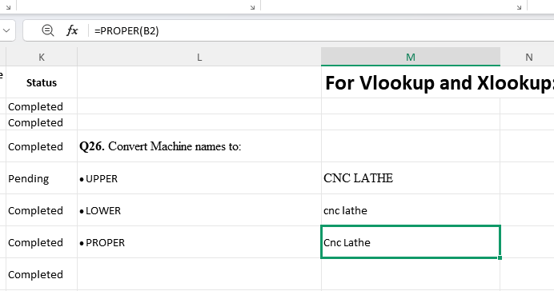
Q27. Use LEN() to find the number of characters in each Machine name.
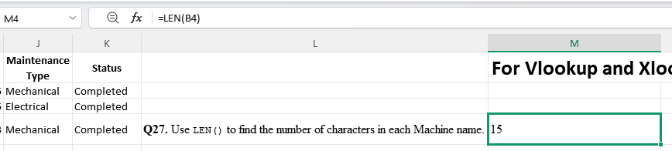
Q28. Use LEFT, RIGHT, or MID to practice extracting parts of Machine ID.
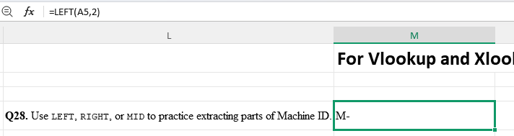
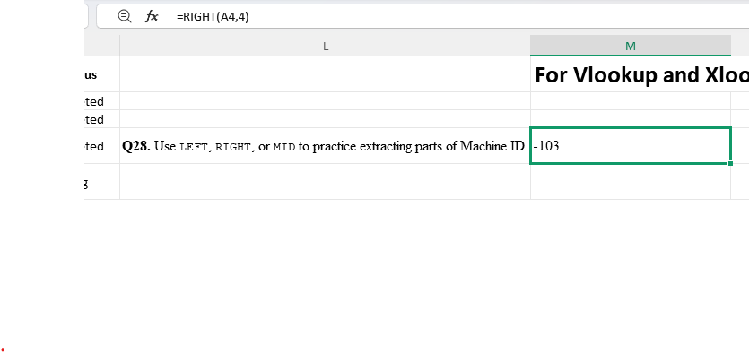
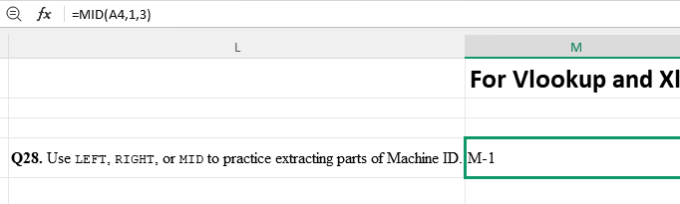

Part G — Named Ranges
Q29. Create a named range:
Production_Data
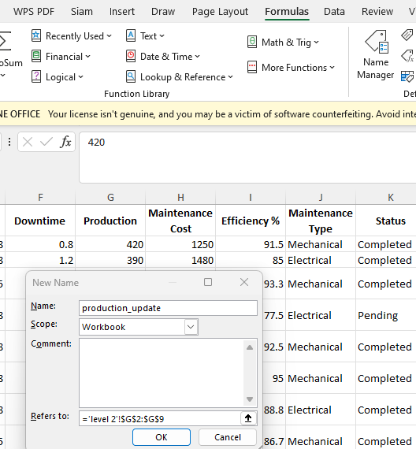
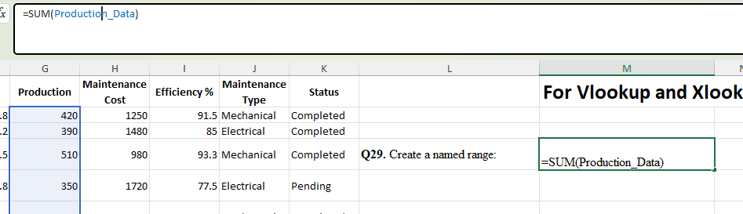
for the Production column.
Q30. Create:
Maintenance_Cost
for Maintenance Cost.
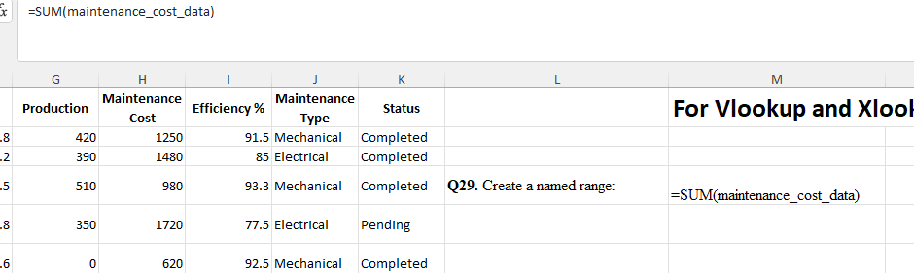
Q31. Use your named ranges in SUM and AVERAGE.
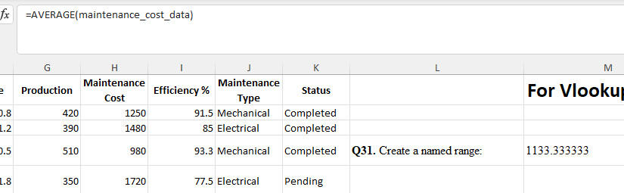

Part H — Excel Tables
Q32. Convert your dataset into an Excel Table.
Use:
Ctrl + T
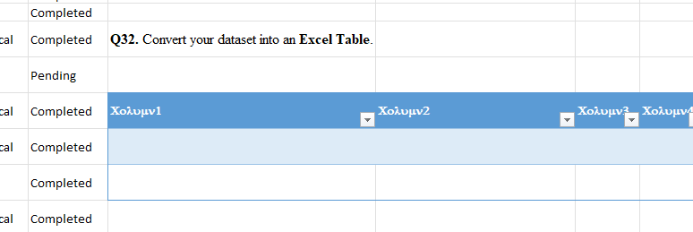
Q33. Give the table a meaningful name such as:
EngineeringData
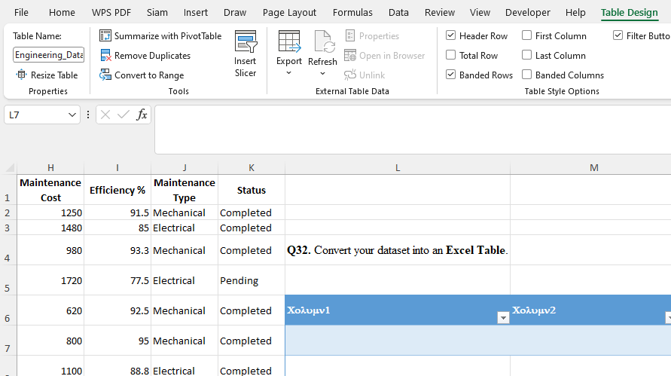

Part I — Advanced Filtering & Sorting
Q35. Show only machines with Pending status.
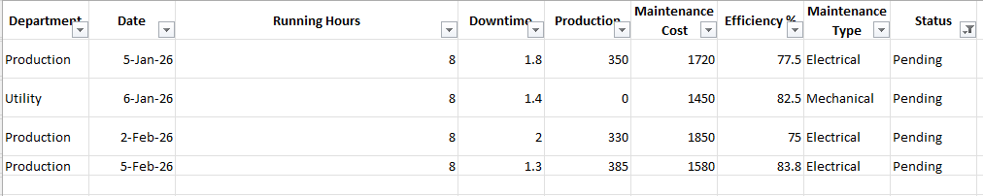
Q36. Show machines with Efficiency >90%.
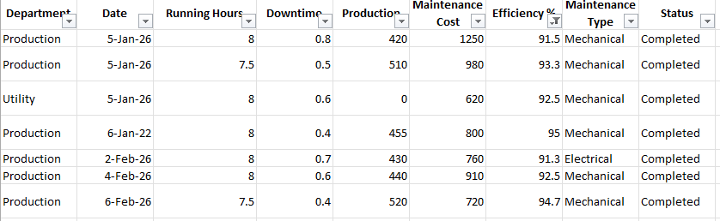
Q37. Show machines with Downtime >1 hour.
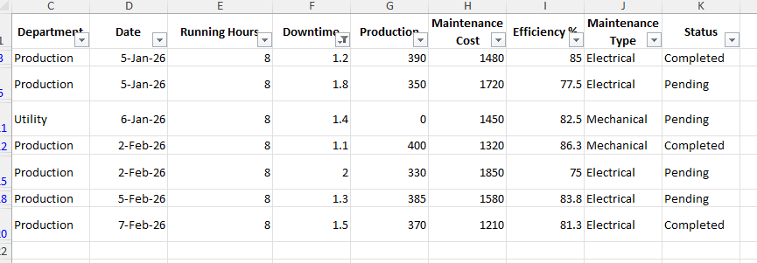
Q38. Sort Efficiency from largest → smallest.
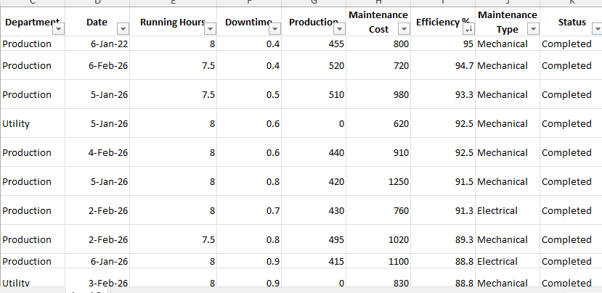
Q39. Sort by:
- Department
- Then Efficiency from largest → smallest
- 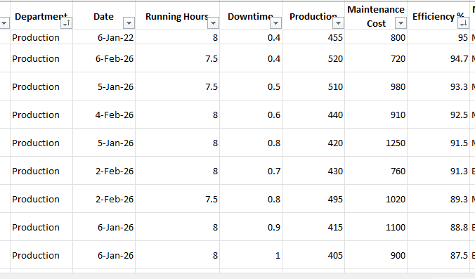

3. Engineering Calculation ⭐⭐⭐
This is the most important part for your career.

Q40 — Machine Utilization
Calculate:
Utilization % = (Running Hours − Downtime) / Running Hours × 100
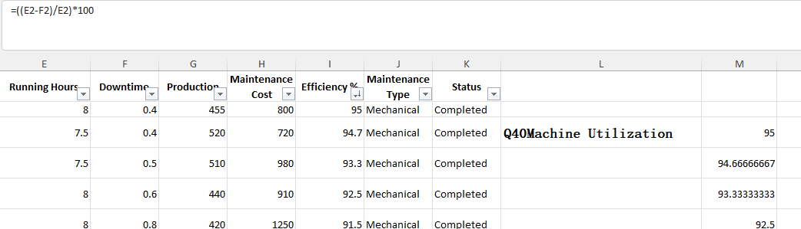

Q41 — Downtime %
Calculate:
Downtime % = Downtime / Running Hours × 100
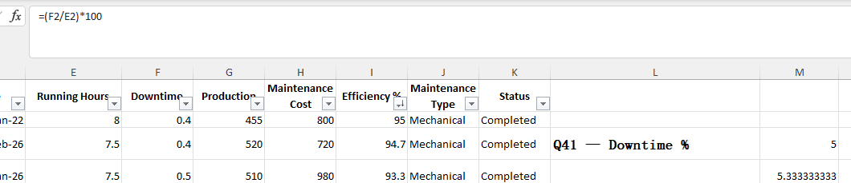

Q42 — Production Rate
Calculate:
Production per Running Hour = Production / Running Hours
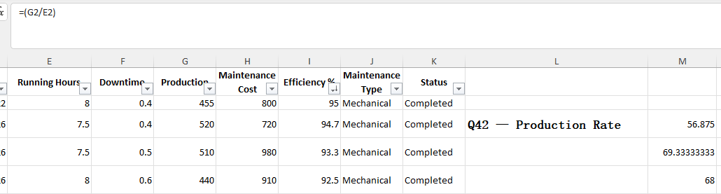

Q43 — Maintenance Cost per Unit
Calculate:
Maintenance Cost per Unit = Maintenance Cost / Production
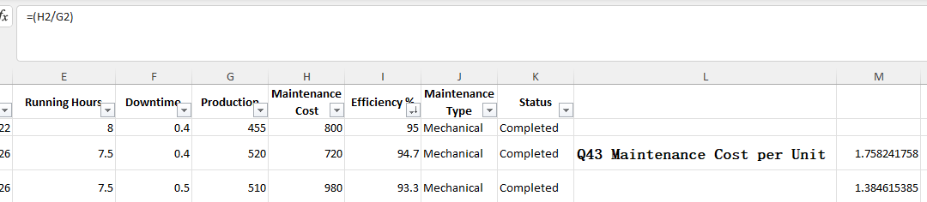

Q44 — Daily Production
Find the total Production for each date.
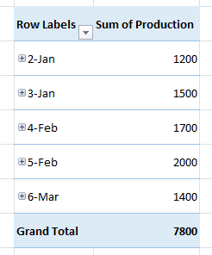

Q45 — Monthly Production
Find:
- January total
- February total
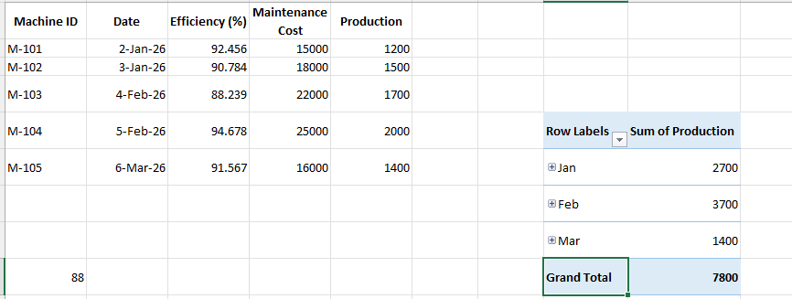

Q46 — Best Machine
Find which machine has the highest average Efficiency.
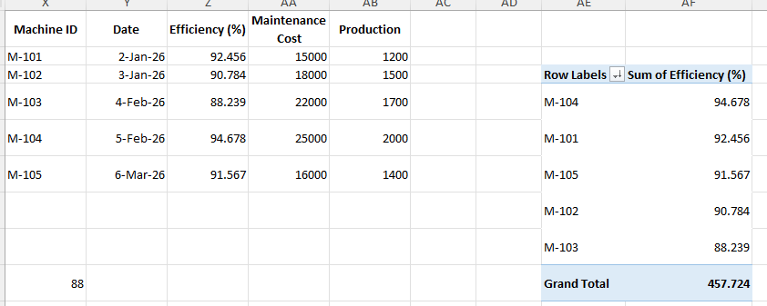

Q47 — Maintenance Problem
Find which machine has the highest total Maintenance Cost.
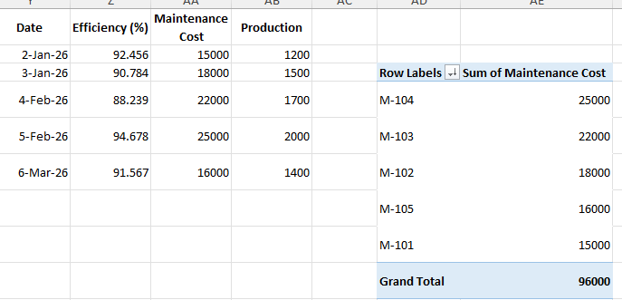

4. Final Manager Report ⭐⭐⭐
Finally create a Final_Report sheet.
Make this:
KPI | Value
Total Production | ?
Average Efficiency | ?
Total Downtime | ?
Total Maintenance Cost | ?
Pending Maintenance Records | ?
Best Machine | ?
Then create:

🟢 Top Performing Machines
Rule:
Efficiency ≥ 90% AND Downtime ≤ 1 hour

🔴 Machines Needing Attention
Rule:
Efficiency < 85% OR Status = Pending
Then use:
- Formulas
- Conditional Formatting
- Filter
- Sort
- Excel Table

